Assignment 18.3

Below is the dataset which we will be using for this Assignment in all problems. It has been kept in local file system:

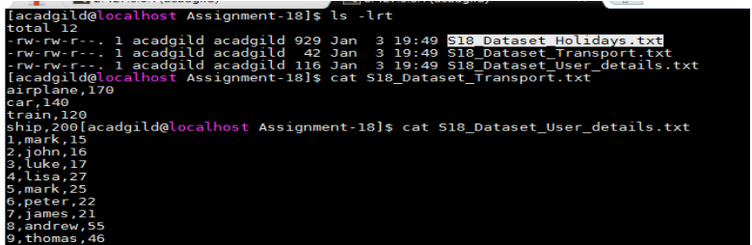

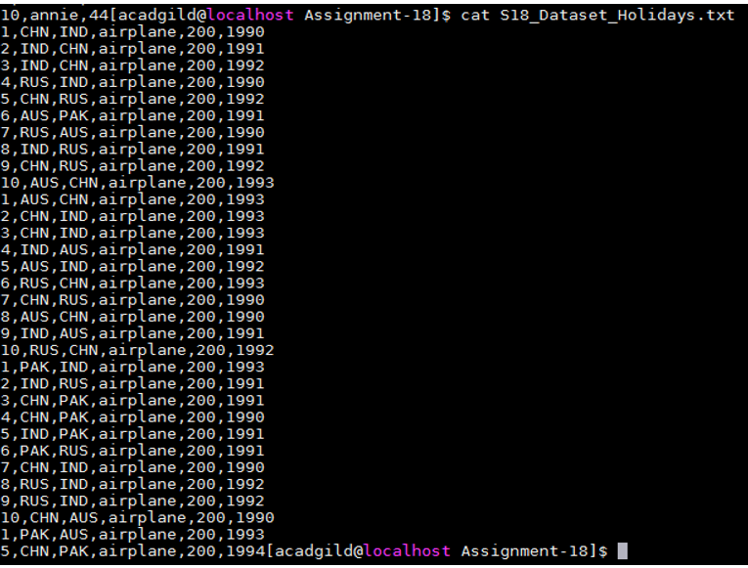

DataSet is uploaded in as follows:-

val baseRDD1 = sc.textFile("/home/acadgild/Assignment18/S18_Dataset_Holidays.txt")

val baseRDD2 = sc.textFile("/home/acadgild/Assignment18/S18_Dataset_Transport.txt")

val baseRDD3 = sc.textFile("/home/acadgild/Assignment18/S18_Dataset_User_details.txt")

import org.apache.spark.storage.StorageLevel

baseRDD1.persist(StorageLevel.MEMORY_ONLY)

baseRDD2.persist(StorageLevel.MEMORY_ONLY)

baseRDD3.persist(StorageLevel.MEMORY_ONLY)

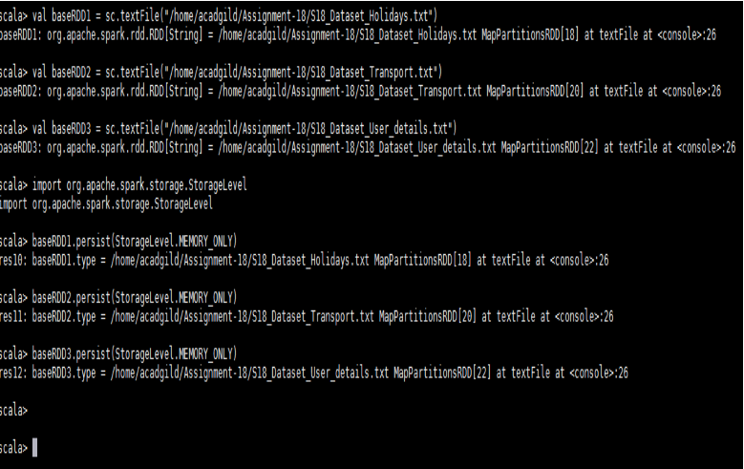

Problem Statement:-

1. Considering age groups of < 20 , 20-35, 35 > ,Which age group spends the most amount of money travelling.

2. What is the amount spent by each age-group, every year in travelling?

Solution:-

• Considering age groups of < 20 , 20-35, 35 > ,Which age group spends the most amount of money travelling.

Below is the code used:-

val travel = baseRDD1.map(x => (x.split(",")(0).toInt,x.split(",")(1),x.split(",")(2),x.split(",")(3),x.split(",")(4) .toInt,x.split(",")(5).toInt))

val transport = baseRDD2.map(x => (x.split(",")(0),x.split(",")(1).toInt))

val user = baseRDD3.map(x => (x.split(",")(0).toInt,x.split(",")(1),x.split(",")(2).toInt))

val AgeMap = user.map(x => x._1 -> {if(x._3<20) "20" else if(x._3>35) "35" else "20-35" })

val userMap = travel.map(x => x._4 -> (x._1,x._5))

val transportmap = transport.map(x=> x._1 -> x._2)

val joinCost = userMap.join(transportmap)

val calCost = joinCost.map(x => x._2._1._1 -> x._2._1._2 * x._2._2)

val groupCost = calCost.groupByKey().map(x => x._1 -> x._2.sum)

val groupAgeCost = AgeMap.join(groupCost).map(x => x._2._1 -> x._2._2)

val finalCost = groupAgeCost.groupByKey().map(x => x._1 -> x._2.sum)

val maxVal = finalCost.sortBy(x => -x._2).first()

Output:-

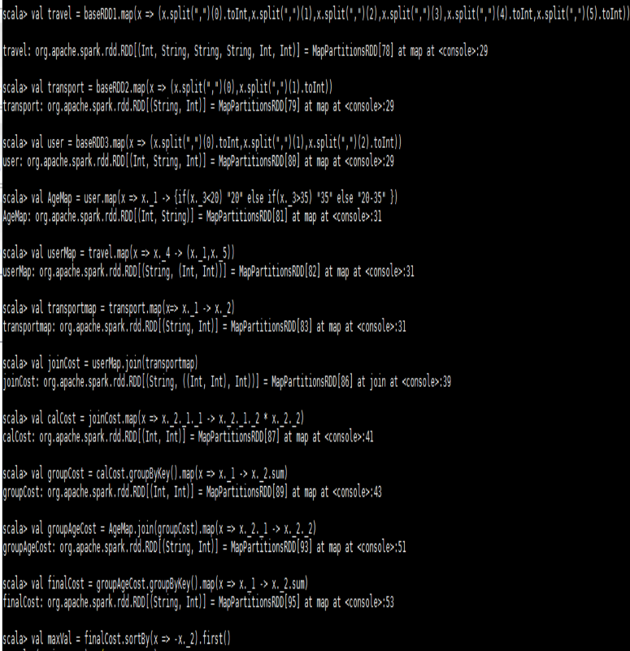

• What is the amount spent by each age-group, every year in travelling?

Below is the code used:-

val UserYearMap = travel.map(x => x._4 -> (x._1,x._5,x._6))

val transportmap = transport.map(x=> x._1 -> x._2)

val UserCost = UserYearMap.join(transportmap)

val CalcCost = UserCost.map(x => x._2._1._1 -> (x._2._1._3,x._2._1._2 * x._2._2))

val AgeMap = user.map(x => x._1 -> {if(x._3<20) "20" else if(x._3>35) "35" else "20-35" })

val CostMap = AgeMap.join(CalcCost).map(x => (x._2._1,x._2._2._1) > x._2._2._2)

val ExpPeryear = CostMap.groupByKey().map(x => x._1 -> x._2.sum)

ExpPeryear.foreach(println)

Output:-

